Oracle 12c - Step by Step Installation

Download software from below link.
http://www.oracle.com/technetwork/database/enterprise-edition/downloads/index.html

Unzip the software
unzip linuxamd64_12102_database_1of2.zip
unzip linuxamd64_12102_database_2of2.zip

cd to database software folder and run installer

cd database
[oracle@localhost database]$ ./runInstaller

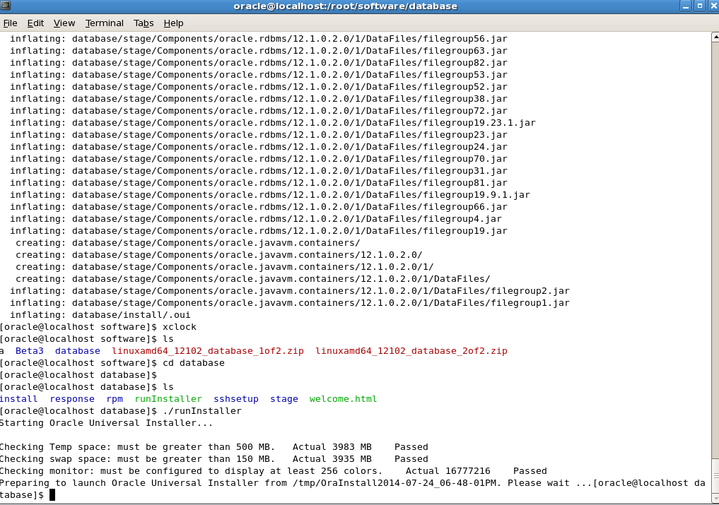

You need to provide your MOS username and password here. You can ignore this and move on too.

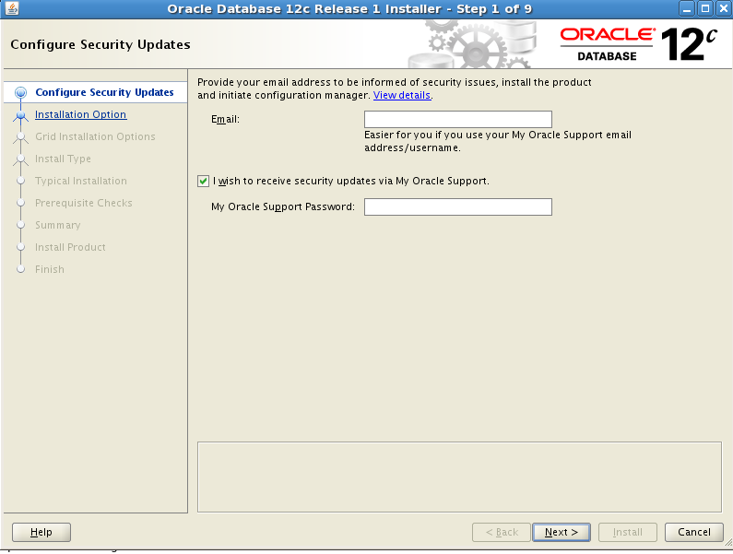

Uncheck security update check box unless you want security update

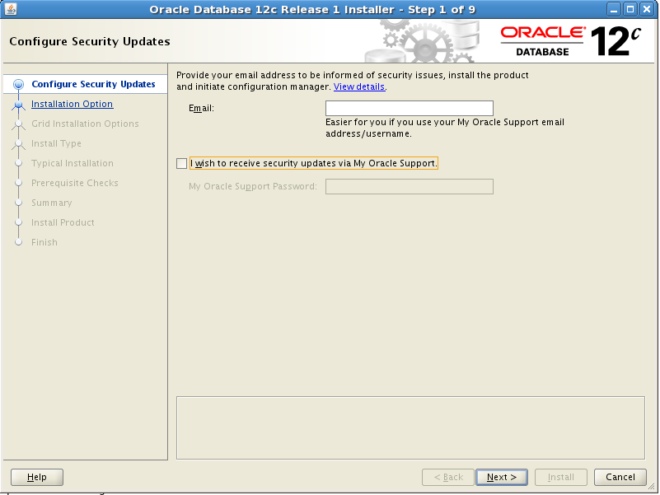

Hit yes to move to next screen

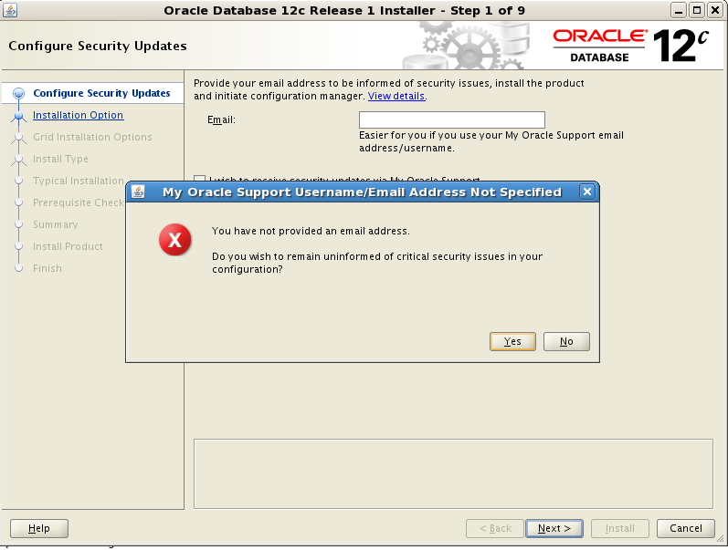

Here you have options
- Install software and create database
- Install software only
- Upgrade an existing database.

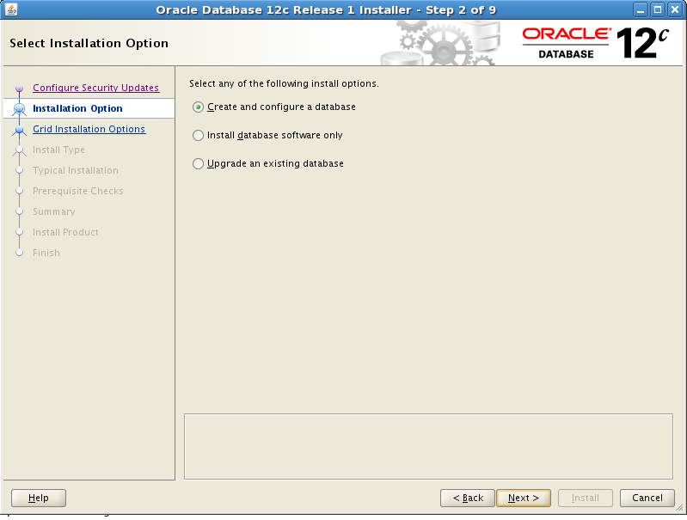

Choose if you want to create database for testing purpose on your PC
Or a production install on a server class machine

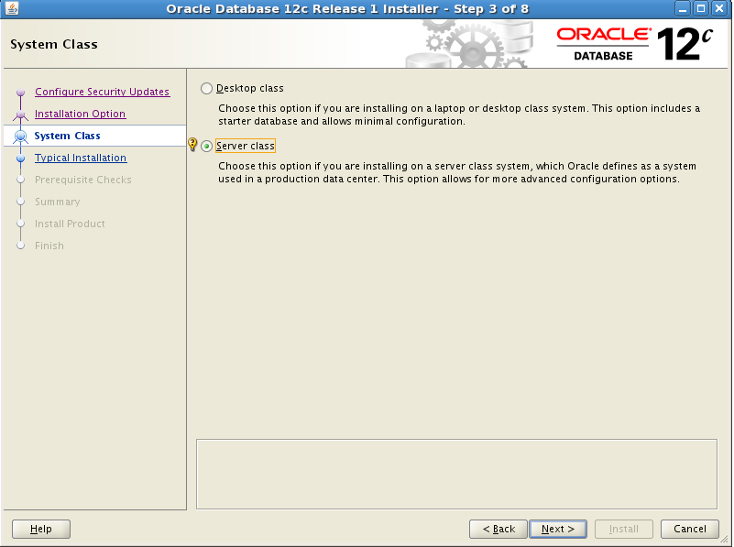

Select your option for Non Rac / RAC or RAC one node

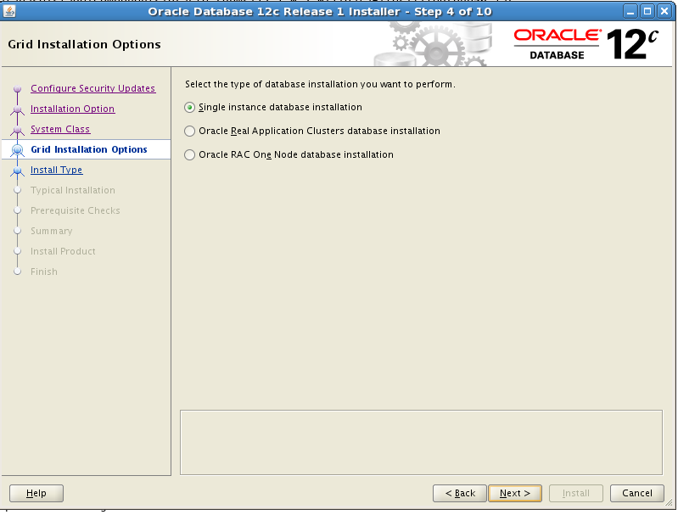

Options for typical or advance install. Most of installs are good as typical. Advanced option is for experienced DBA’s but they also do not use it very often.

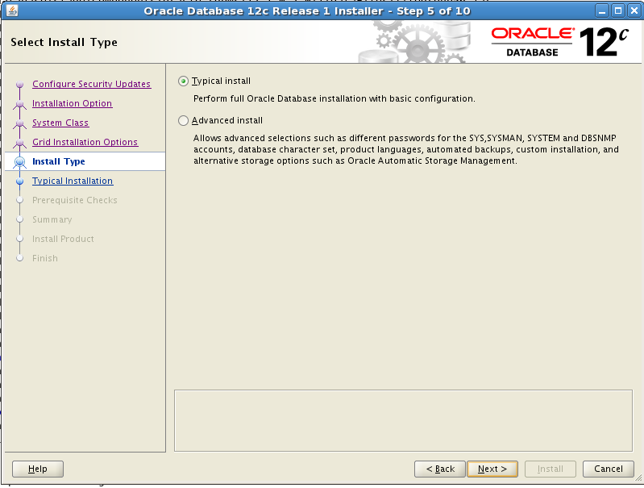

Options to select path for Oracle Home and provide administrative password.

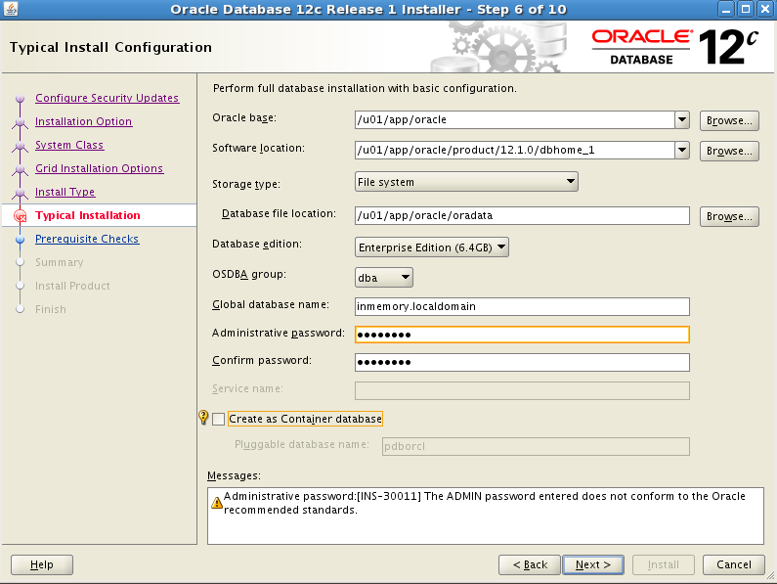

You have to provide a strong password else it will complain. If you hit yes you can ignore this and go with weak password.

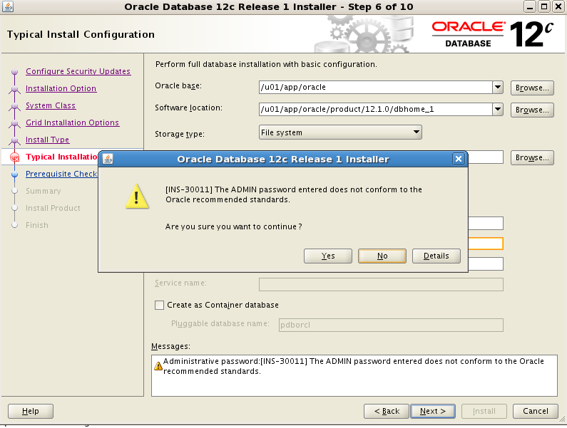

It will show you path for orainventory

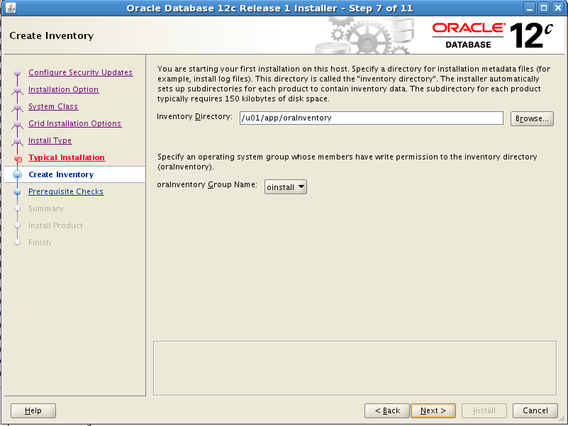

Prereq check failed for Swap .It can be ignored but seriously not recommended

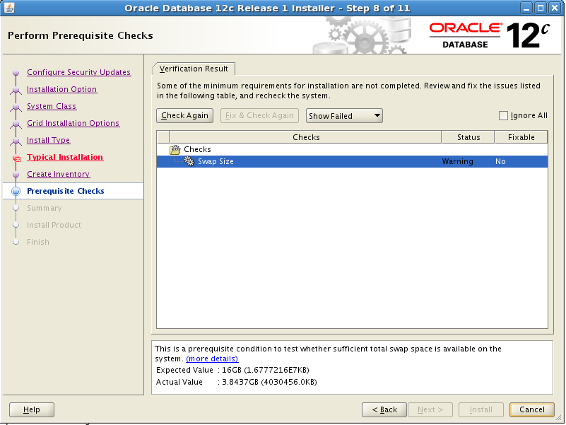

I ignored here for testing purpose with check box

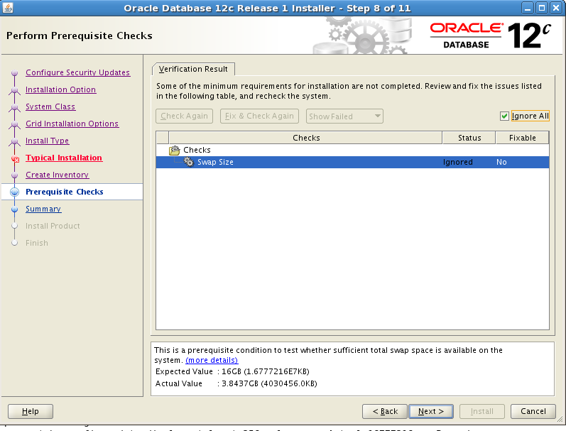

Press yes to confirm

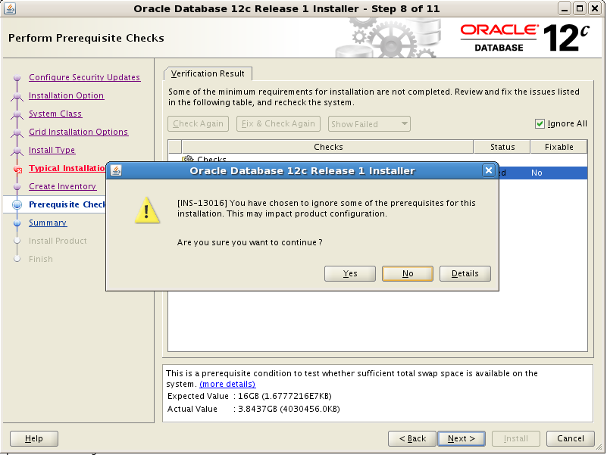

It will show all the information about this install .Press install button

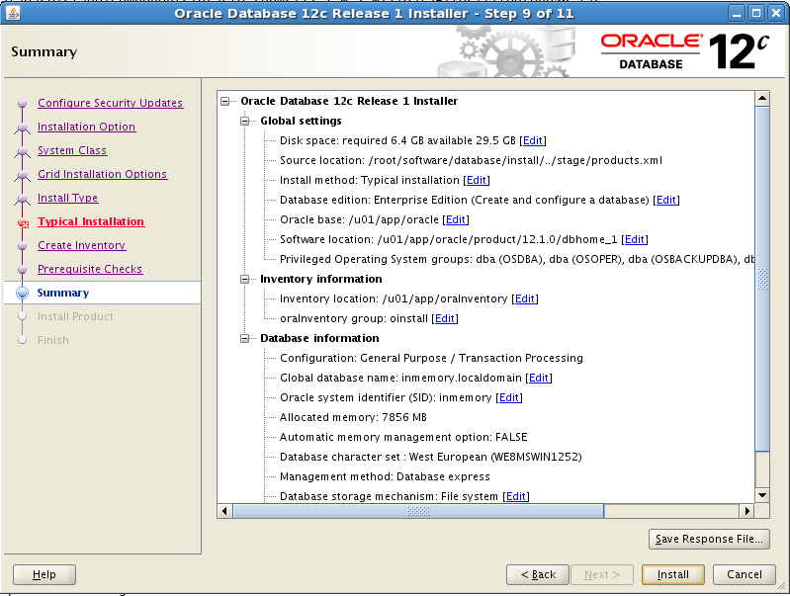

See progress

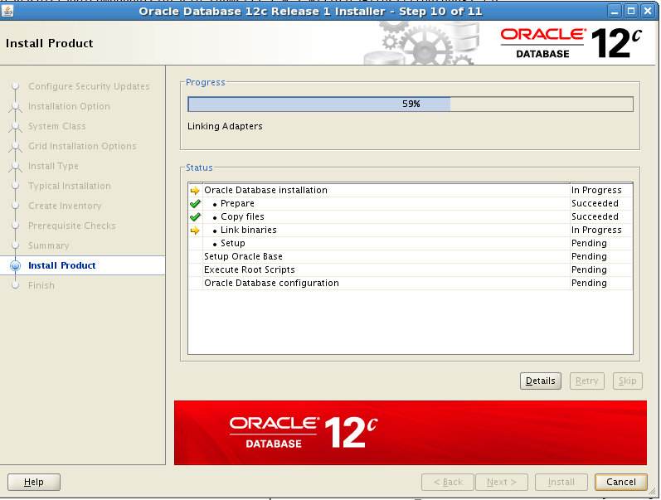

It will ask you to run two root.sh scripts

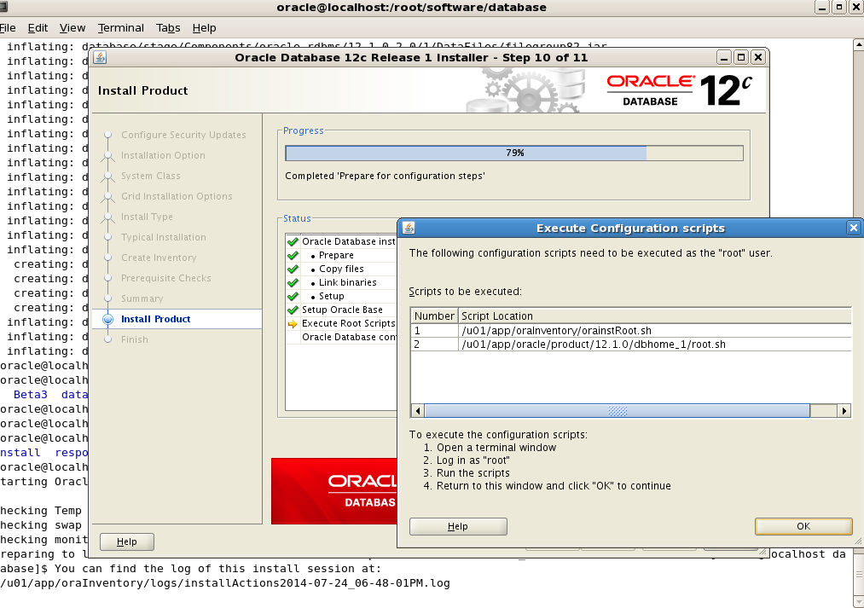

Below screen showing running orainstRoot.sh

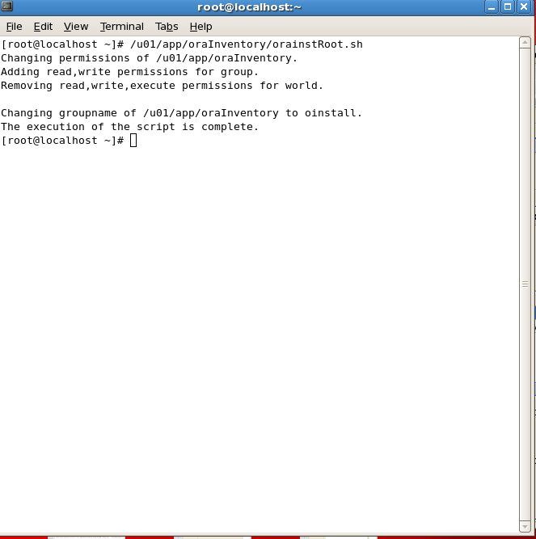

Below screen is showing running root.sh

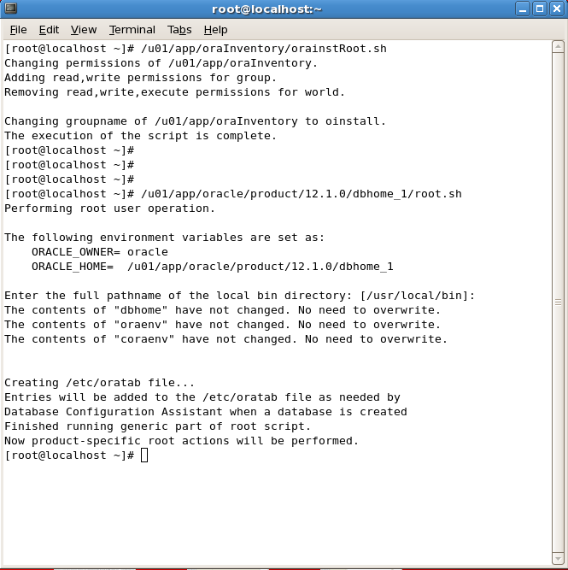

Since I choose to create database it launched DBCA

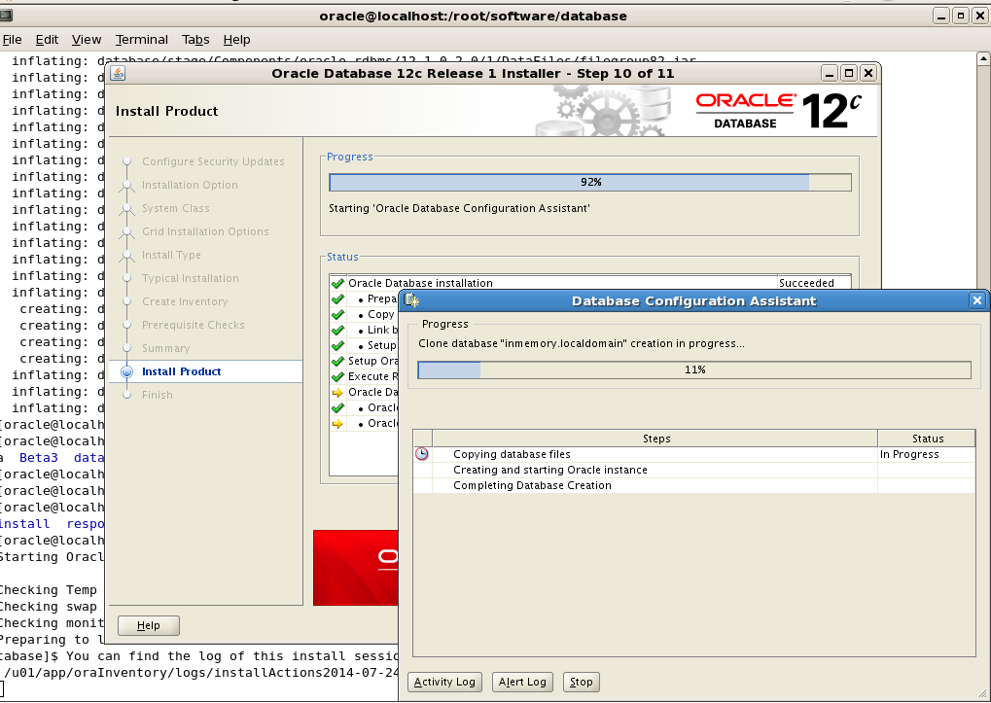

You can see process by clicking alert log button

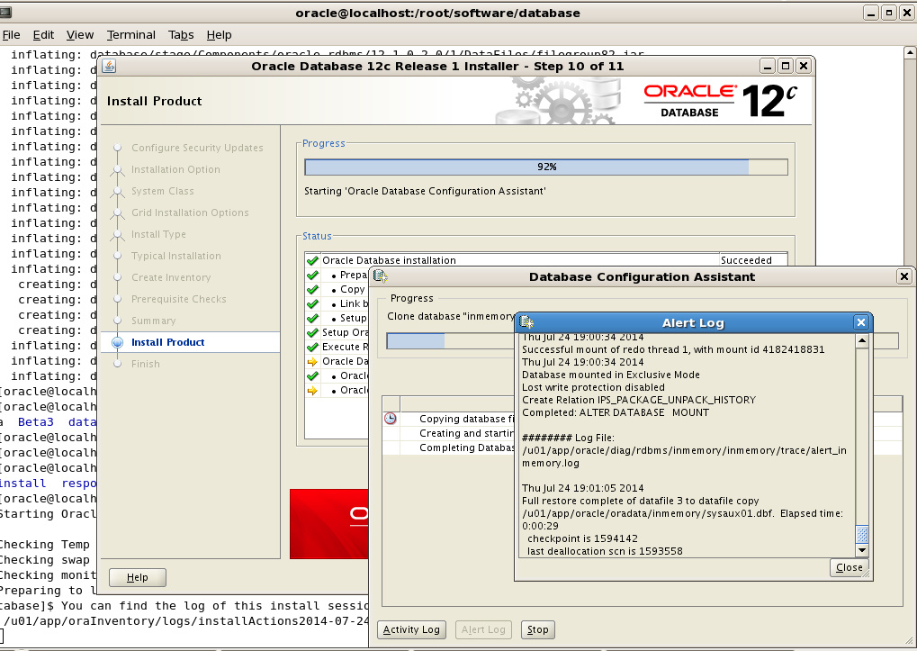

Once this is all done you can connect to 12.1.0.2 database with in-memory option…

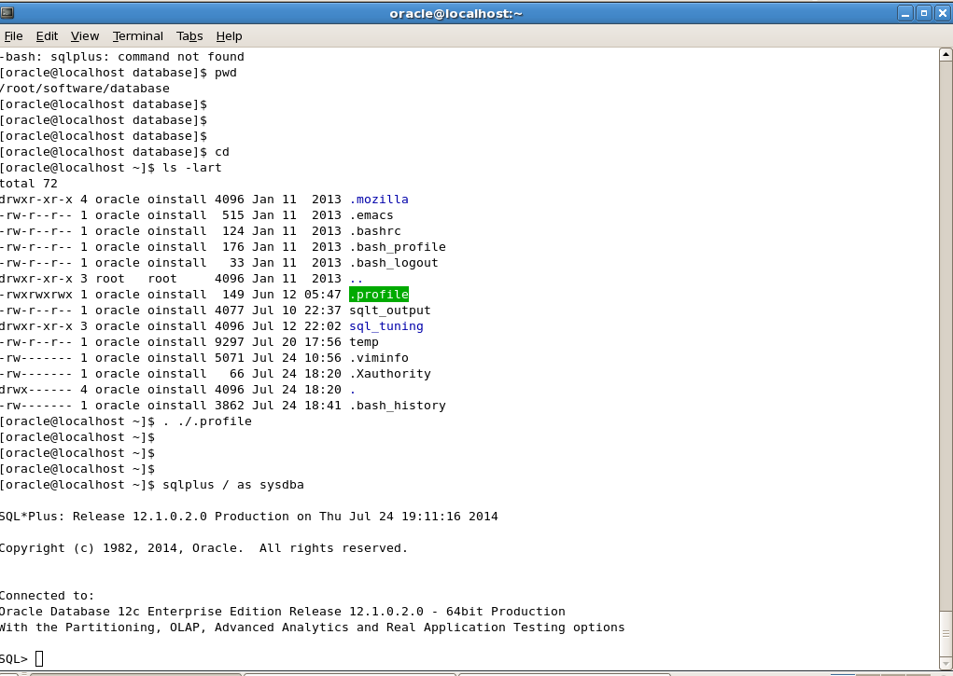

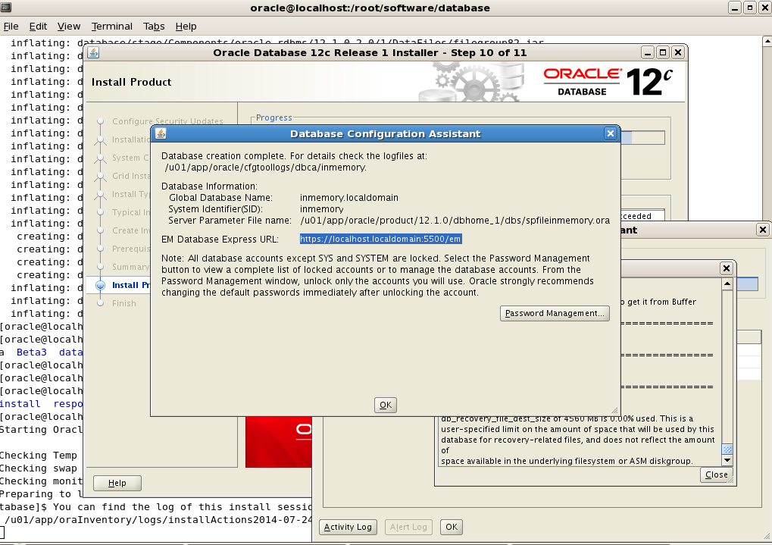

Thanks for checking this. Further you can read how to test In-Memory option by clicking below article

http://www.oracle-12c.com/articla_det.asp?articleID=9&topicID=3&tName=Oracle12c

